**U2.Exit task**

**Sadovskaya Veronika**

GitHub: <https://github.com/sdveronika/DataMola22>

**Task 1 - Test Star Data**

**Cleancing level:**

Re-run the script with procedures that fill tables with data from sa level to dw_cl:

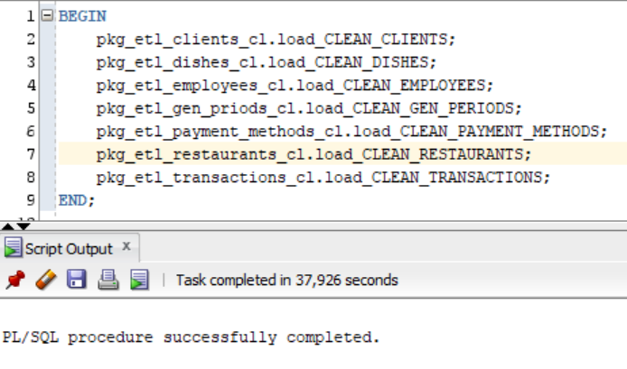

Selects from tables on dw_cl level:

1. dw_cl.cl_t_client

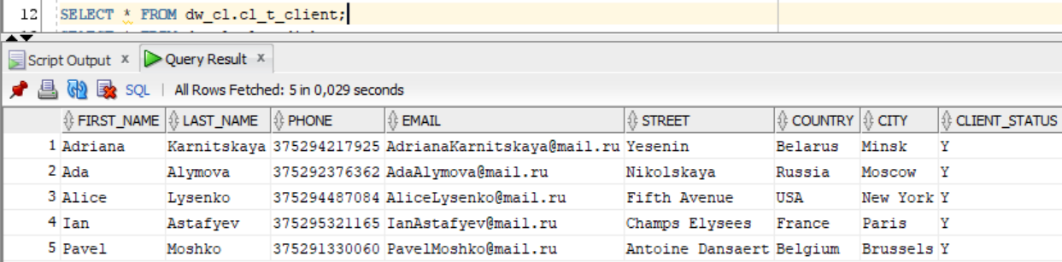

1. dw_cl.cl_t_dish

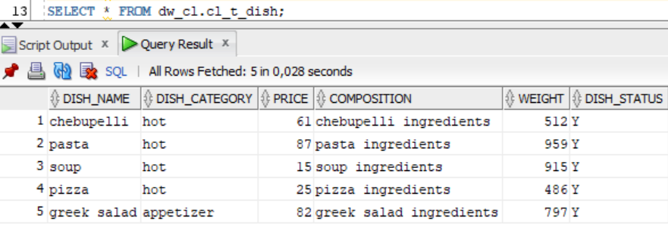

1. dw_cl.cl_t_employee (SCD2)

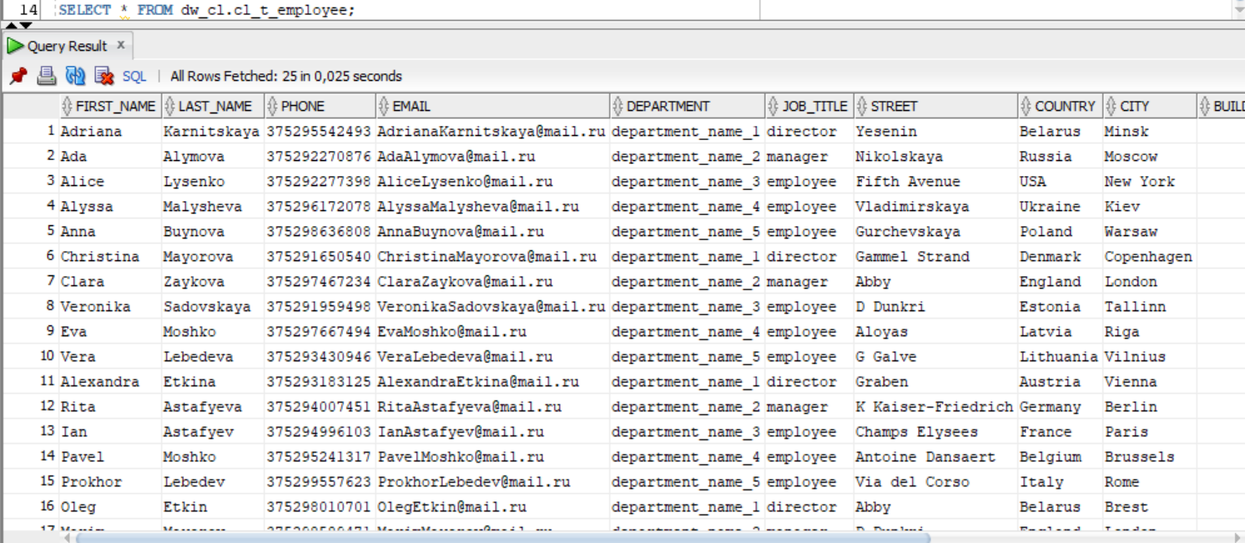

1. dw_cl.cl_t_gen_period

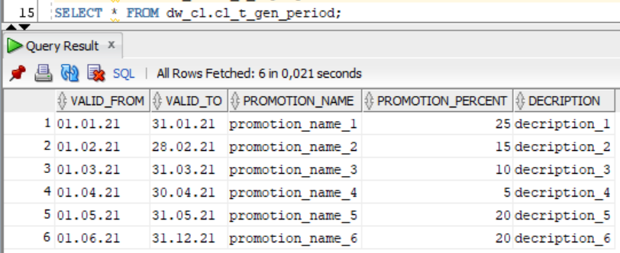

1. dw_cl.cl_t_payment_method

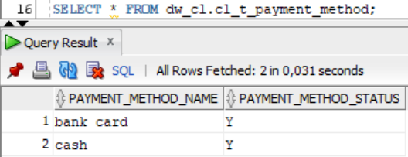

1. dw_cl.cl_t_restaurant

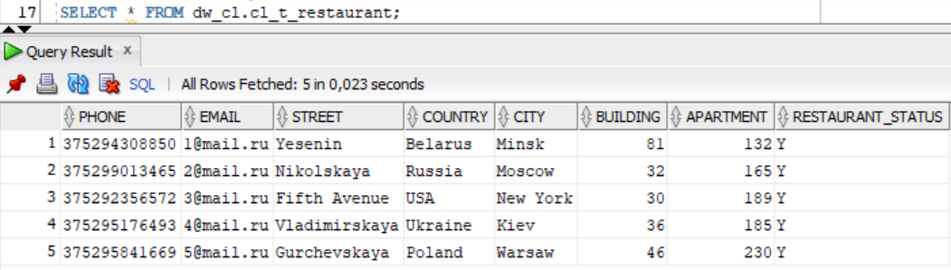

1. dw_cl.cl_t_transaction

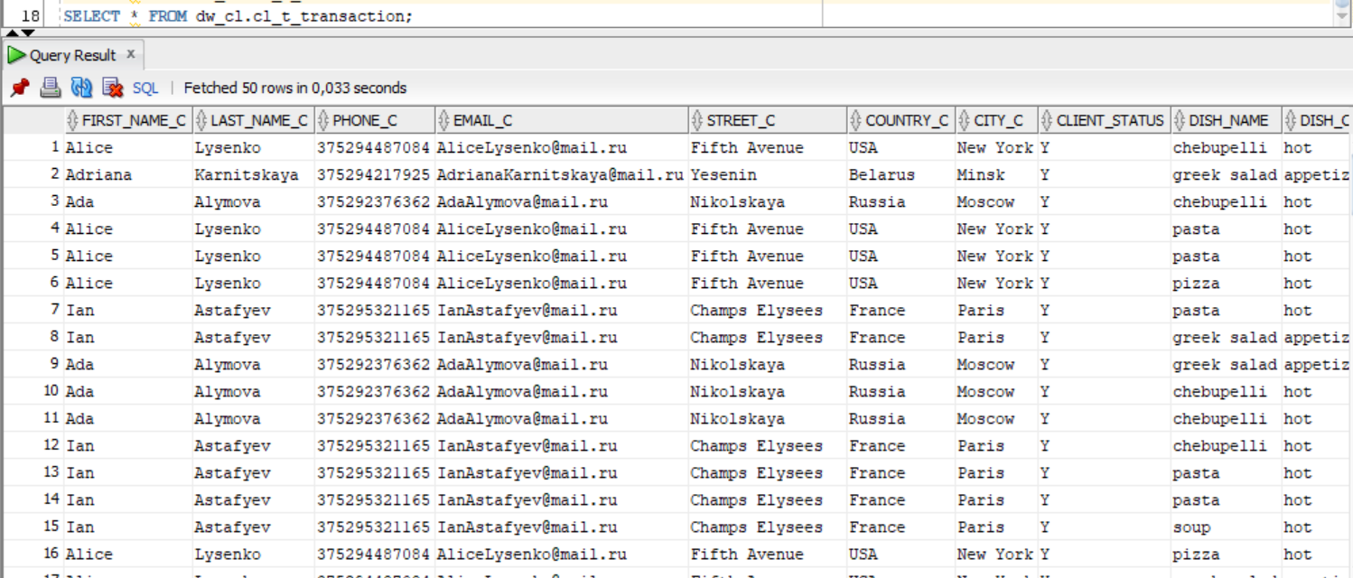

**DW level:**

Re-run the script with procedures that fill tables with data from dw_cl level to dw:

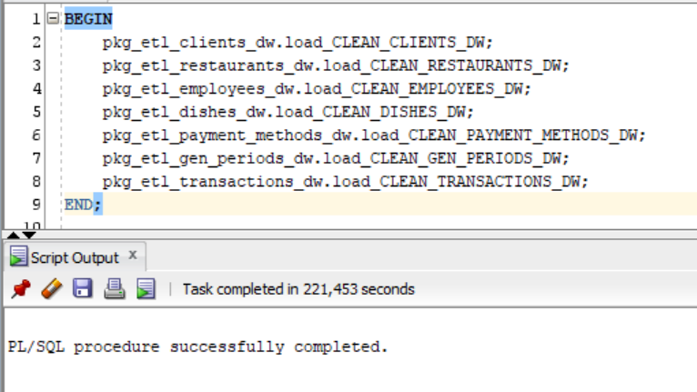

Selects from tables on dw level:

1. dw_data.client_dimension

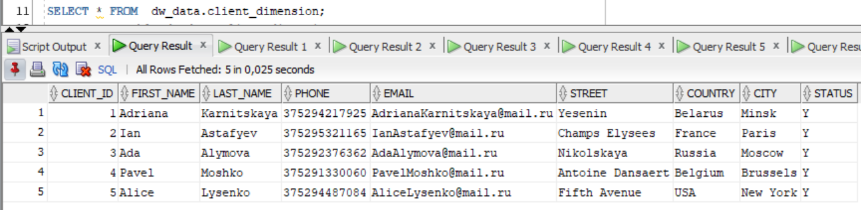

1. dw_data.restaurant_dimension

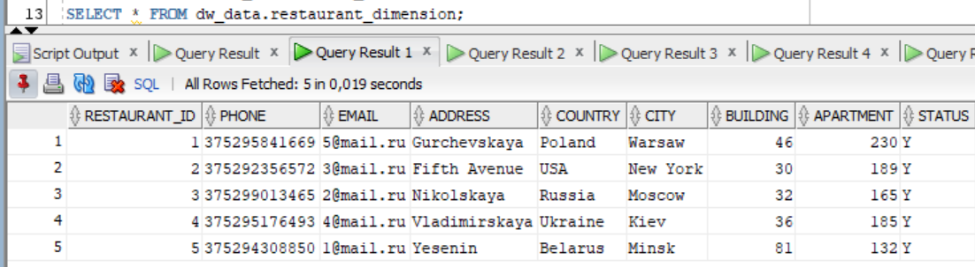

1. dw_data.employee_dimension (SCD2)

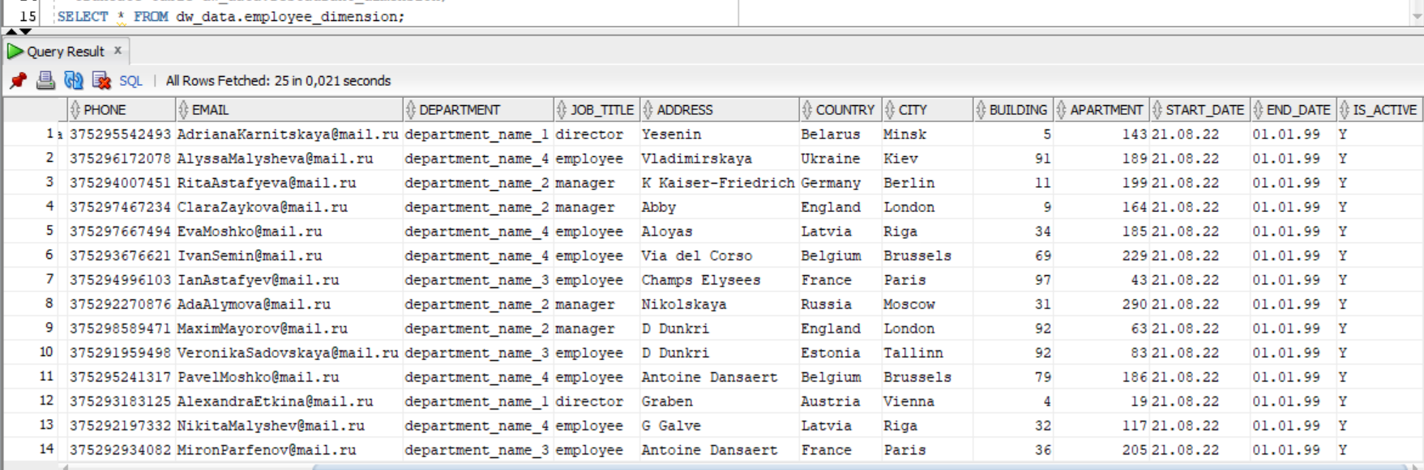

1. dw_data.dish_dimension

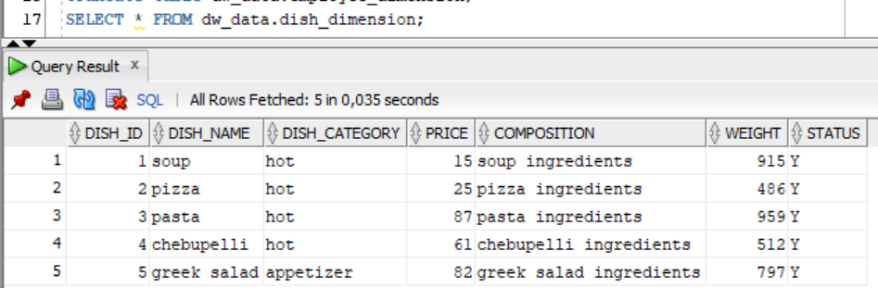

1. dw_data.payment_method_dimension

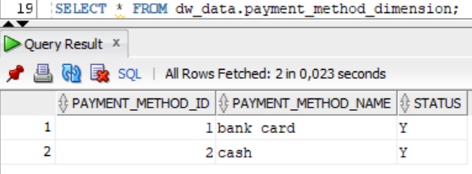

1. dw_data.dim_gen_period

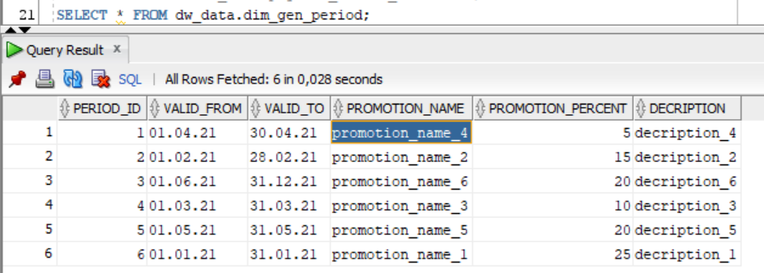

1. dw_data.order_fact

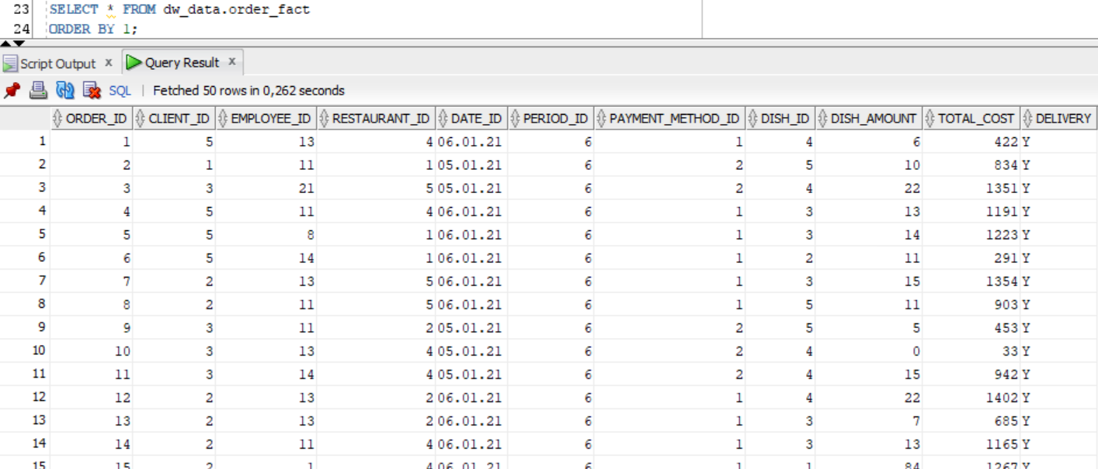

**SAL level:**

Let's create view sal_cl.employee_dim_actual_position that contains information about the duration of work of all employees in the current position:

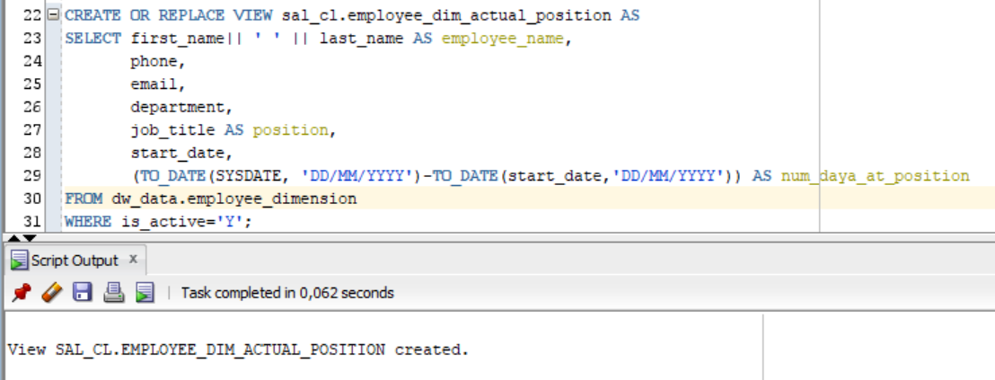

Select from view sal_cl.employee_dim_actual_position:

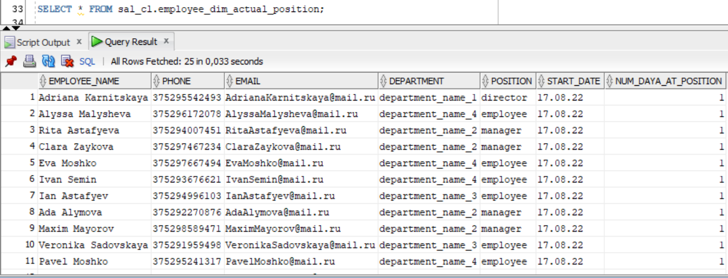

Let's create view sal_cl.employee_dim_work that contains information about the amount of work of each employee per month (number of orders and total profit):

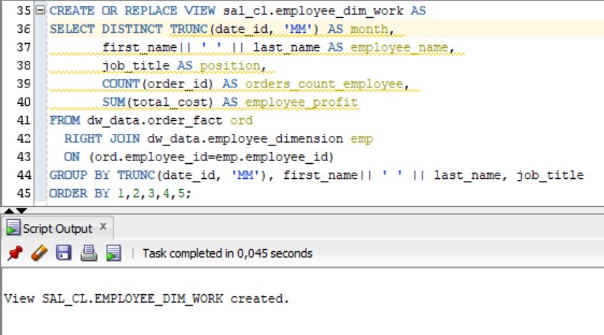

Select from view sal_cl.employee_dim_work:

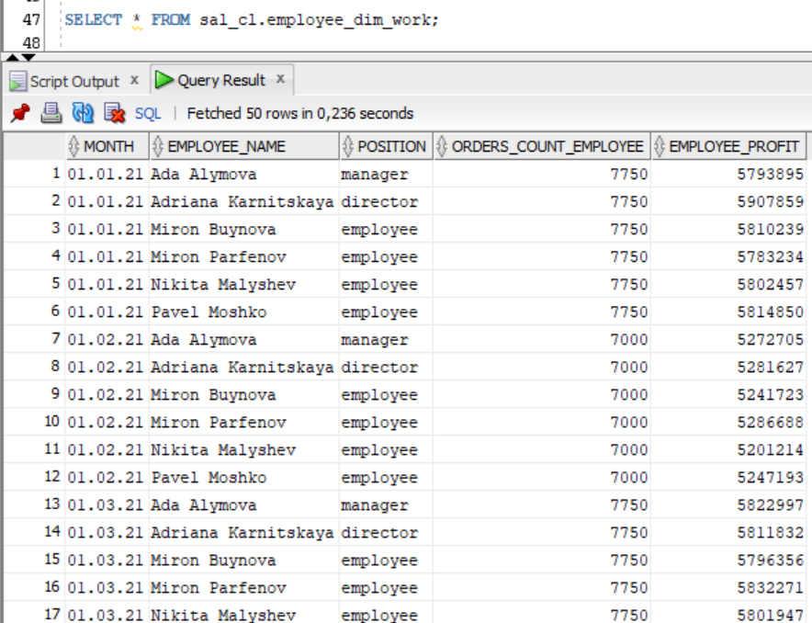

Let's create sal_cl.restaurant_profit view that contains information about the profit for the month for each restaurant, the number of dishes sold and the total number of orders:

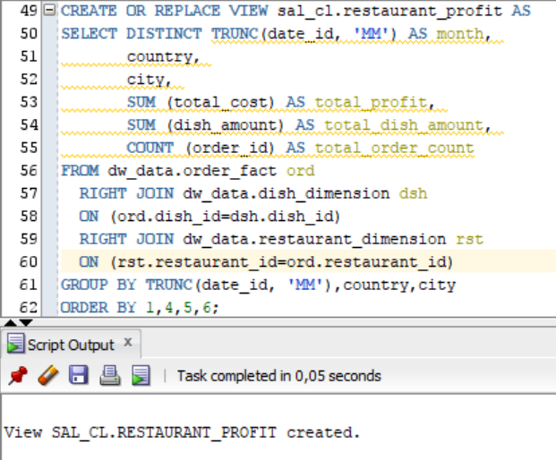

Select from view sal_cl.restaurant_profit:

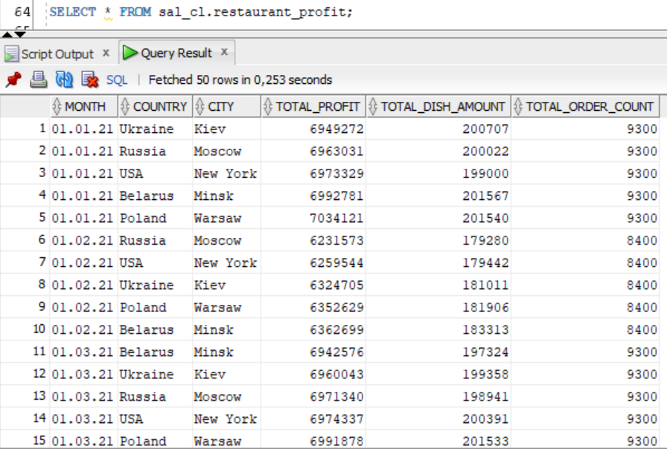

Let's create view sal_cl.top_dishes that contains information about the popularity of each dish in each restaurant for a month:

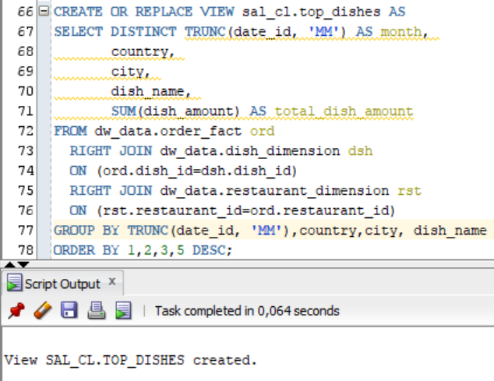

Select from view sal_cl.top_dishes:

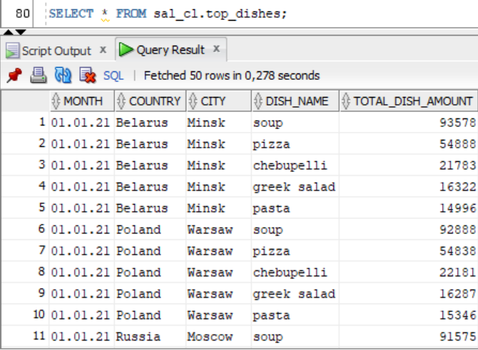

Let's create view sal_cl.restaurant_visits that contains information about the attendance of each restaurant for a month:

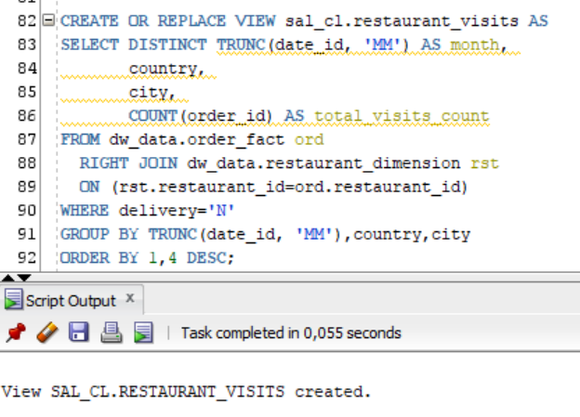

Select from view sal_cl.restaurant_:

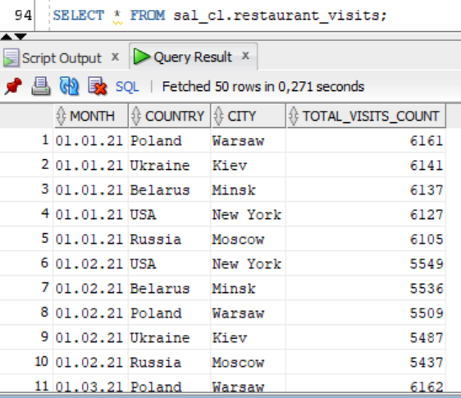

Let's create view sal_cl.w_client_dimansion that stores all information about clients:

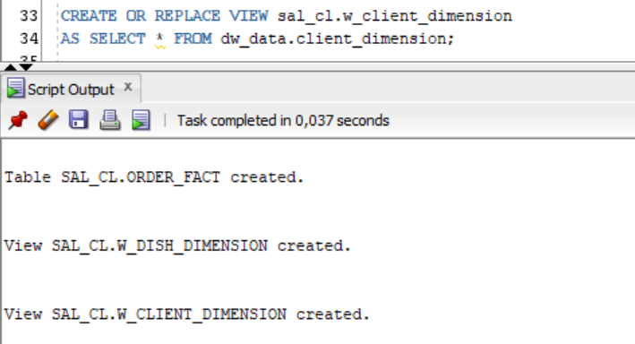

Select from view sal_cl.w_client_dimansion:

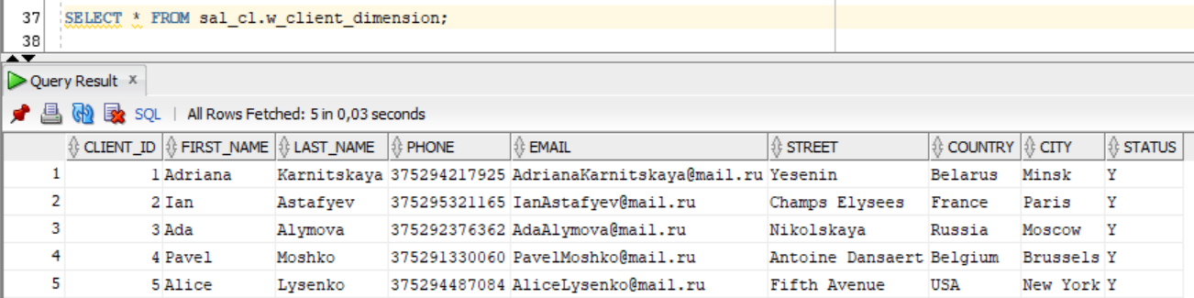

Let's create view sal_cl.w_dish_dimension that stores all information about dishes:

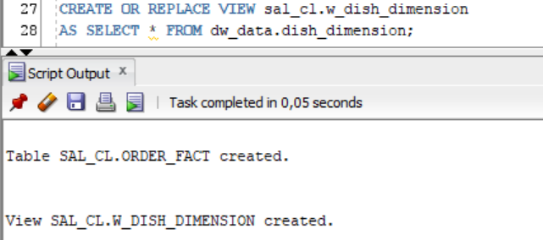

Select from view sal_cl.w_dish_dimension:

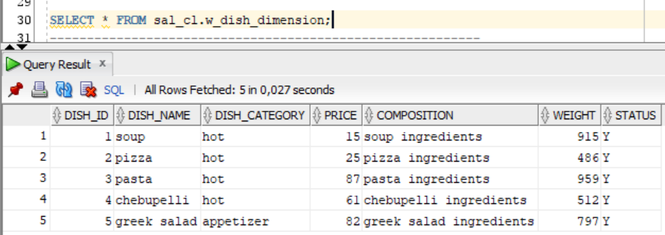

Let's create view sal_cl.w_restaurant_dimension that stores all information about restaurants:

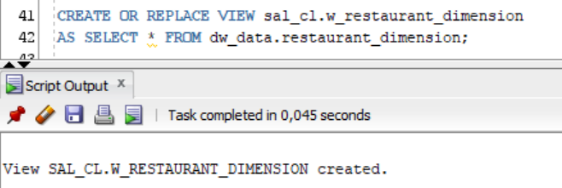

Select from view sal_cl.w_restaurant_dimension:

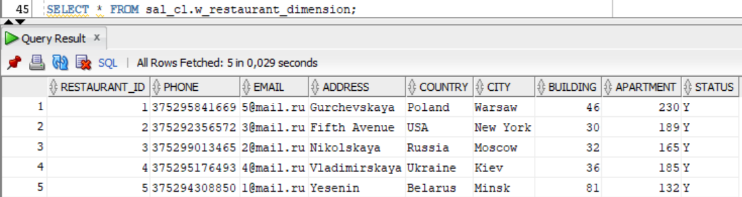

Let's create view sal_cl.w_employee_dimension that stores all information about employees:

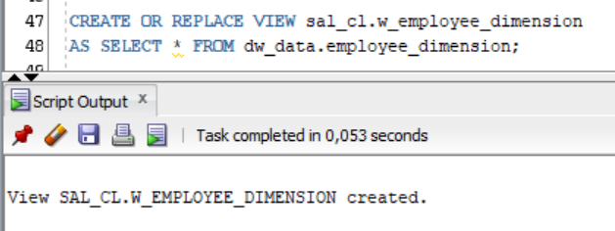

Select from view view sal_cl.w_employee_dimension:

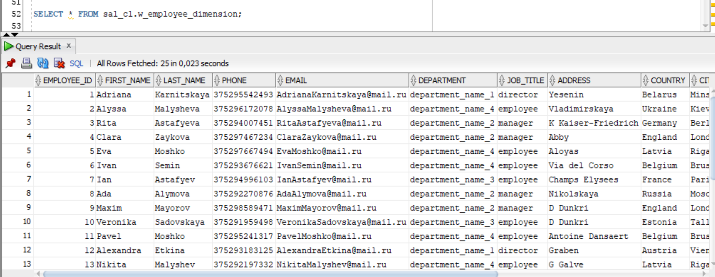

Let's create view sal_cl.w_payment_method_dimension that stores all information about payment methods:

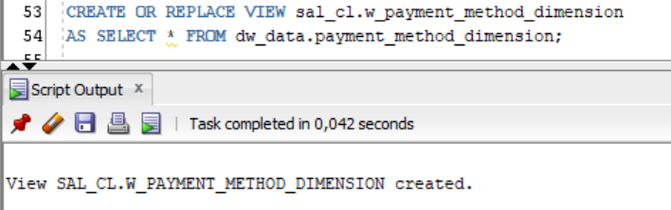

Select from view sal_cl.w_payment_method_dimension:

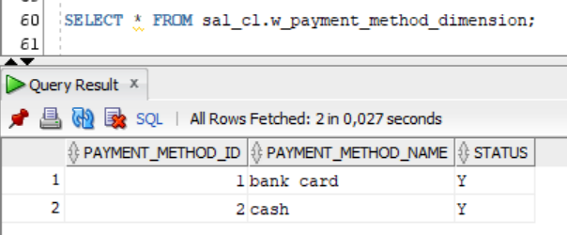

Let's create view sal_cl.w_gen_period that stores all information about gen periods:

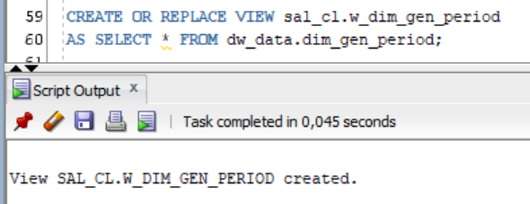

Select from view sal_cl.w_gen_period:

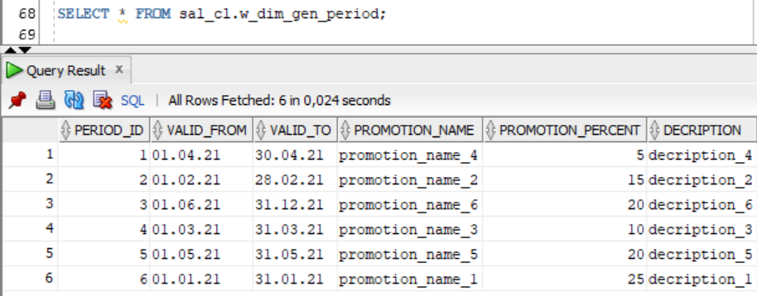

Let's create table sal_cl.order_fact that stores all information about orders:

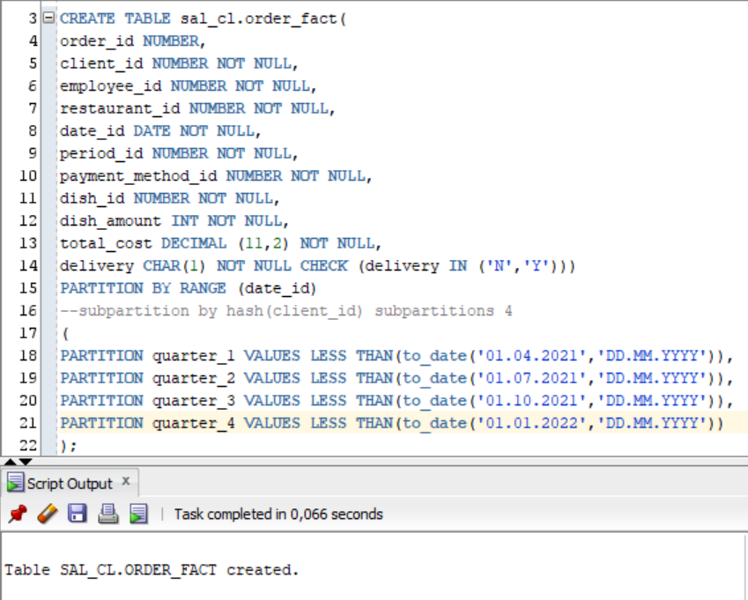

Let’s create package pkg_etl_sal_level and procedure load_sal_order_fact to load data to table sal_cl.order_fact:

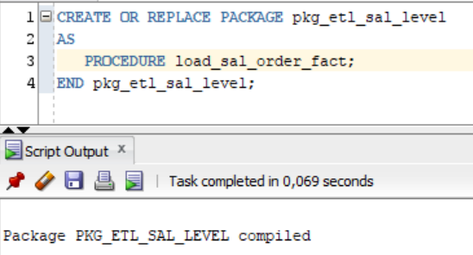

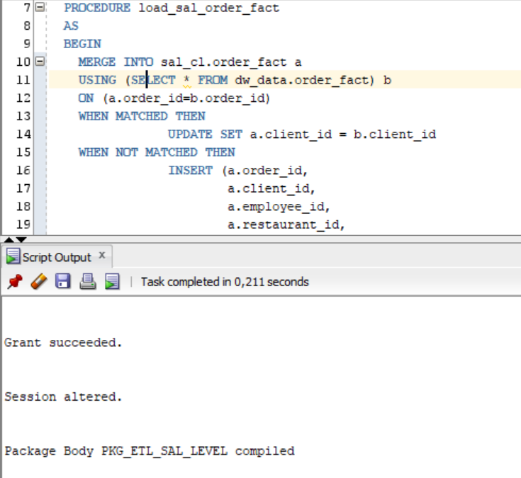

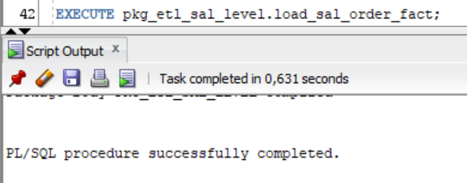

Select from table sal_cl.order_fact:

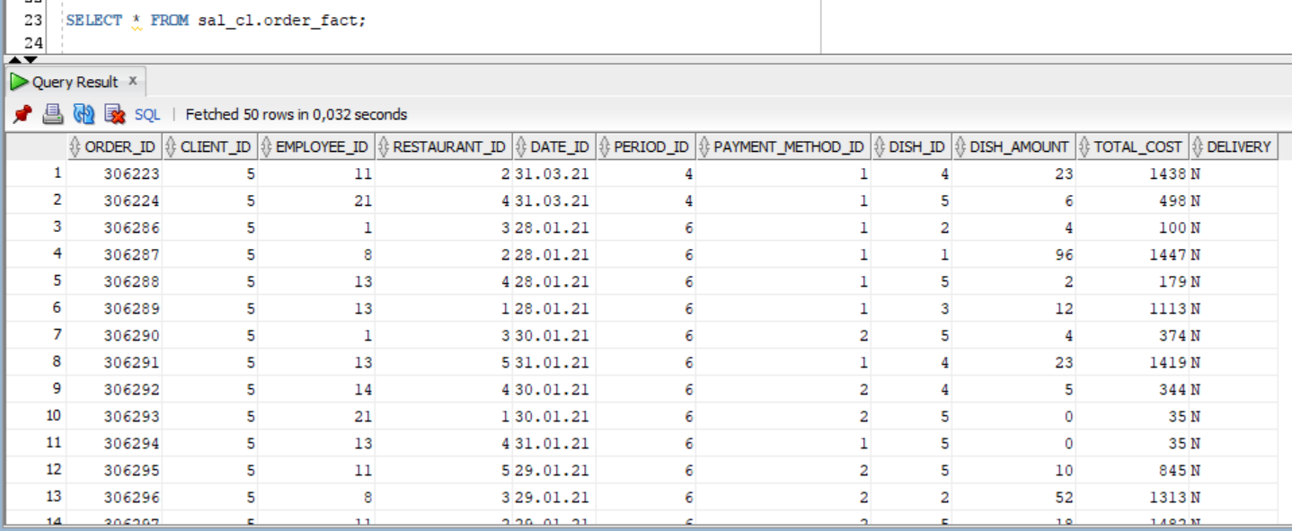

**Star scheme:**

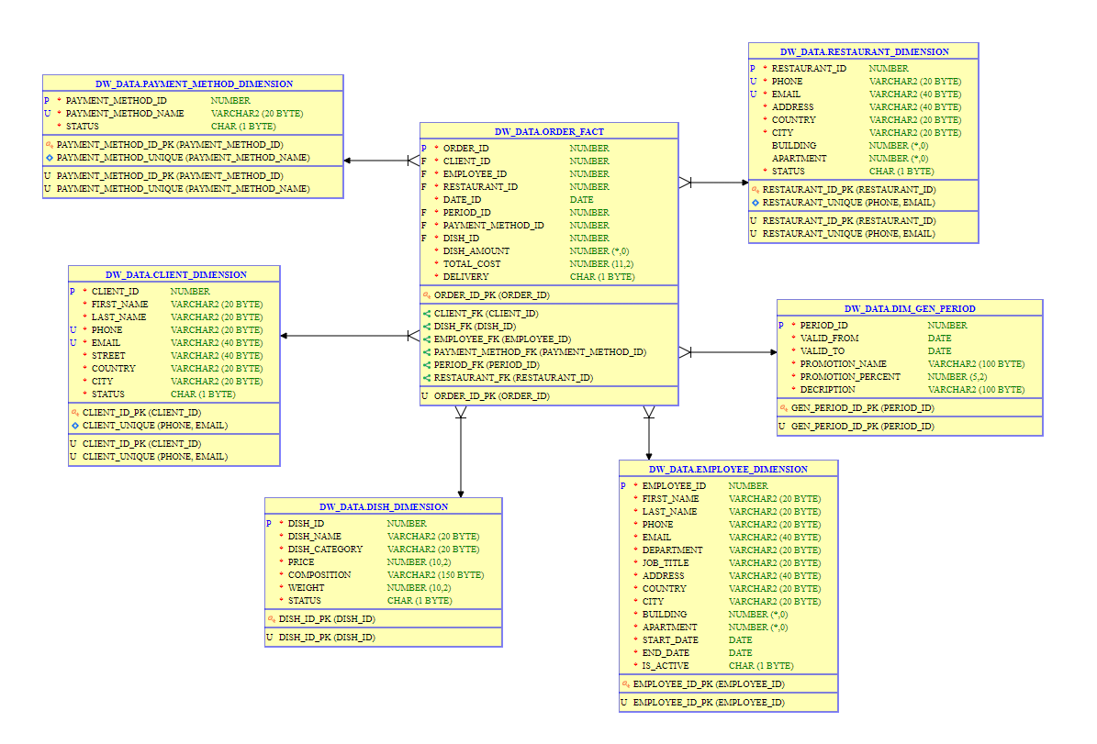

**Statistics for Star Scheme:**

The statistics which is required by cost based optimizer was gathered using DBMS_STATS package. Result of procedure execution for schema is presented below:

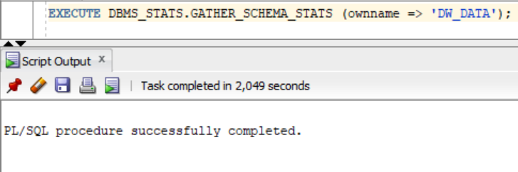

**Task 2 - Performance comparison**

Let's compare 3 queries that get the quantity of each item found in orders:

1. Lab 2, sa level, advancing grouping

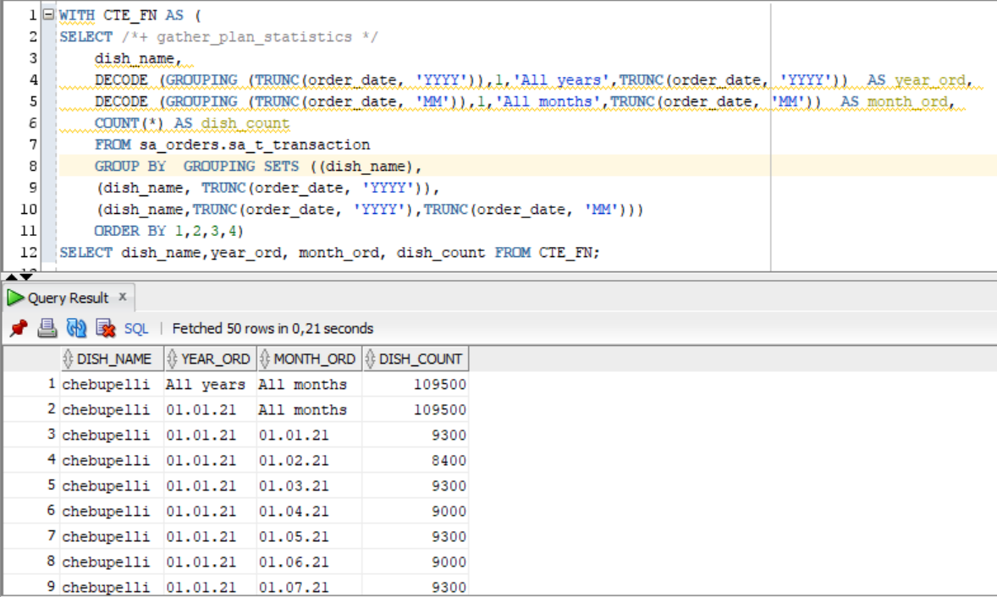

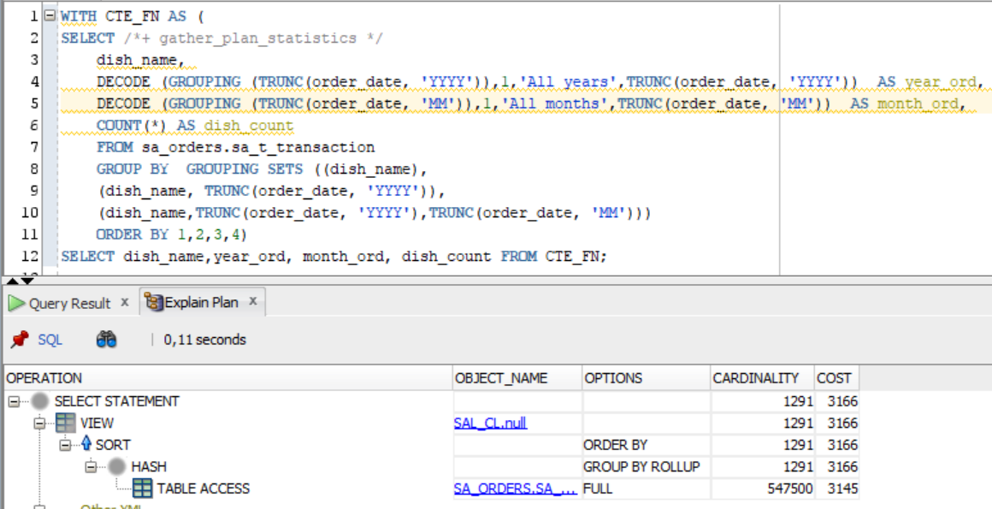

1. Lab 5, sa level, model clause:

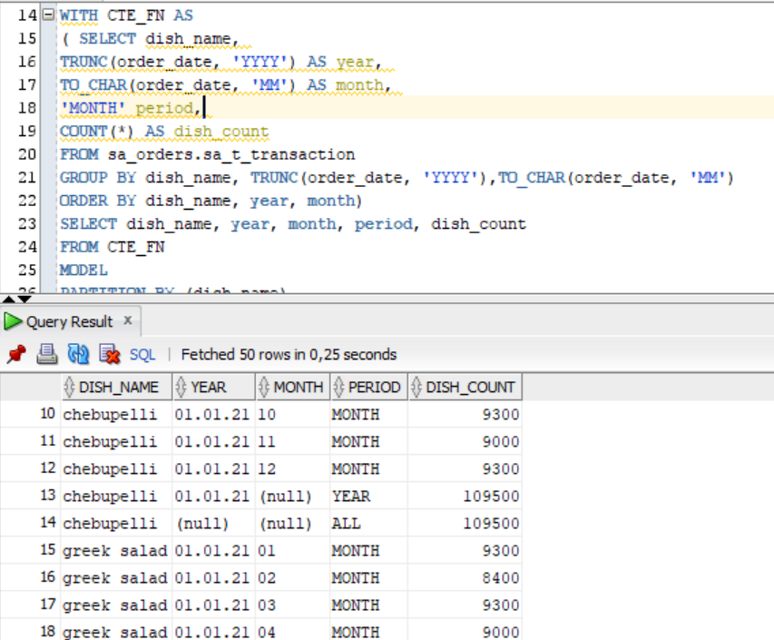

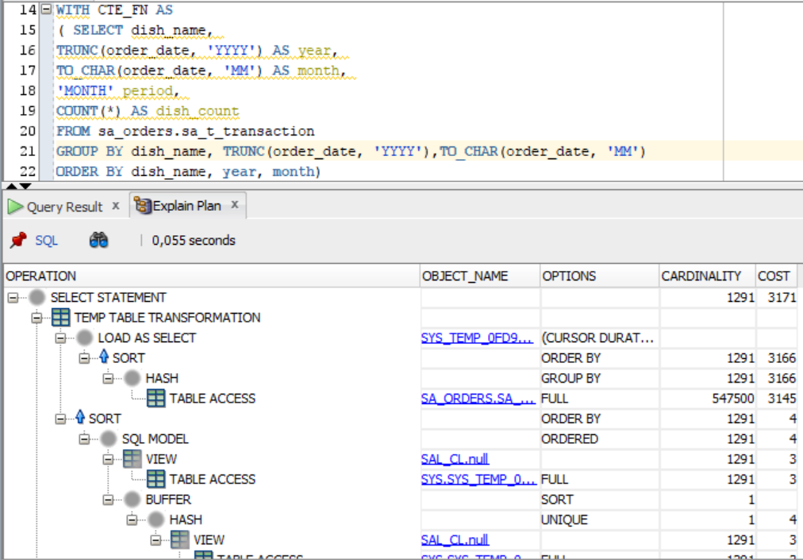

1. Lab 11, dw level, star scheme:

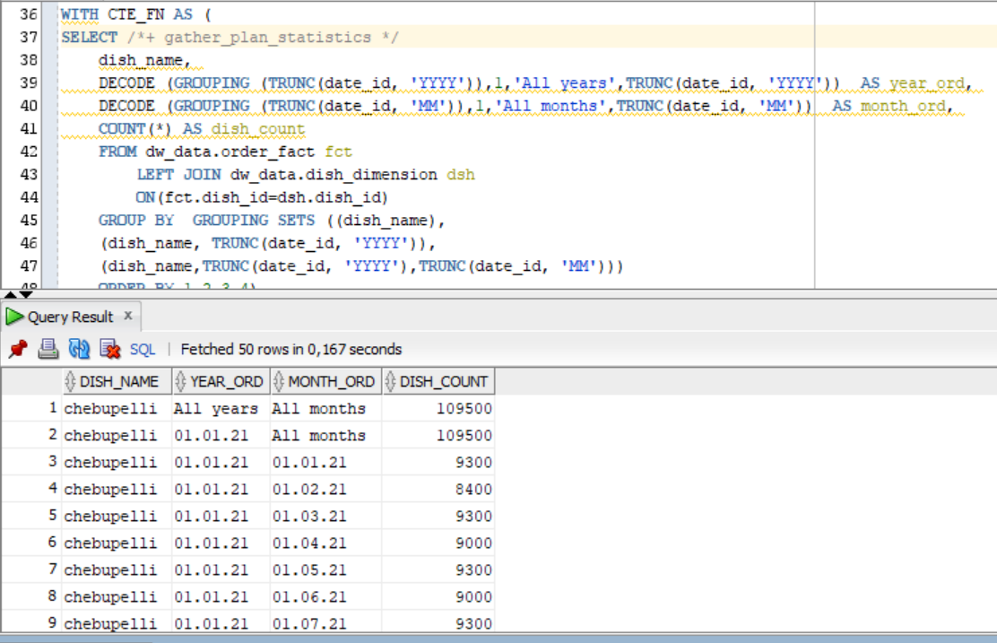

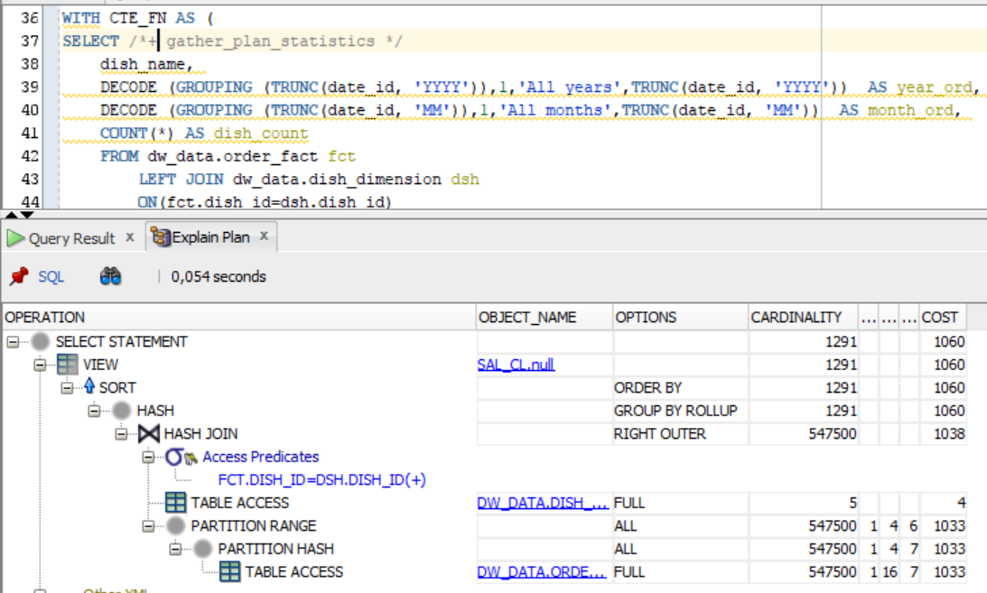

|  |  |  |  |  |
| --- | --- | --- | --- | --- |
| № | Source Type | Explain Plan - Statistics | | Time, Sec. |
| Cardinality | Cost |
| 1 | Lab 2, Advancing Grouping | 1291 | 3166 | 0,21 |
| 2 | Lab 5, Model Clause | 1291 | 3171 | 0,25 |
| 3 | Lab 11, Star Schema | 1291 | 1060 | 0,167 |